Julie Andrews Turns 69, this is hysterical
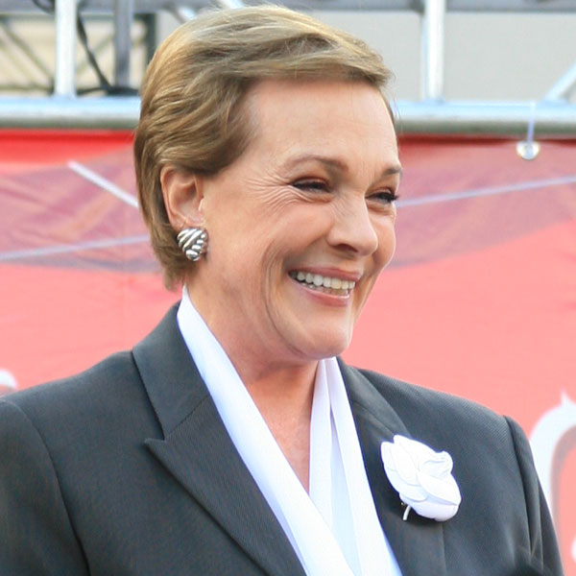
To commemorate her birthday, actress/vocalist, Julie Andrews made a special appearance at Manhattan'sRadioCityMusic Hallfor the benefit of the AARP. One of the musical numbers she performed was 'My Favorite Things' from the legendary movie 'Sound Of Music'. Here are the lyrics she used:
> > > > > > > > > > > > > > > > > > > > > > >> > > > > > > > >
(Sing It!)-
Botox and nose drops and needles for knitting,
Walkers and handrails and new dental fittings,
Bundles of magazines tied up in string,
These are a few of my favorite things.
Cadillacs and cataracts, hearing aids and glasses,
Polident and Fixodent and false teeth in glasses,
Pacemakers, golf carts and porches with swings,
These are a few of my favorite things.
When the pipes leak, When the bones creak,
When the knees go bad,
I simply remember my favorite things,
And then I don't feel so bad.
Hot tea and crumpets and corn pads for bunions,
No spicy hot food or food cooked with onions,
Bathrobes and heating pads and hot meals they bring,
These are a few of my favorite things.
Back pain, confused brains and no need for sinnin',
Thin bones and fractures and hair that is thinnin',
And we won't mention our short shrunken frames,
When we remember our favorite things.
When the joints ache, When the hips break,
When the eyes grow dim,
Then I remember the great life I've had,
And then I don't feel so bad.
> > > > > > > > > > > > > > > > > > > > > > > > > > > > > > > >> >
(Ms. Andrews received a standing ovation from the crowd
that lasted over four minutes and repeated encores. Please
share Ms. Andrews' clever wit and humor with others who
would appreciate it

